Pokhara University

Level: Bachelor | Semester – Fall | Year : 2008
Programme: BE |  | Full Marks : 100
Course: Basic Electrical Engineering |  | Time : 3hrs.

Candidates are required to give their answers in their own words as far as practicable.
The figures in the margin indicate full marks.

Attempt all the questions.

1. | - State and explain Norton's theorem for DC circuit analysis.  - State and explain KVL. Find R_{AB} by using Delta to Star conversion technique.  A  3Ω  5Ω  5Ω  5Ω  B  5Ω  3Ω  7Ω  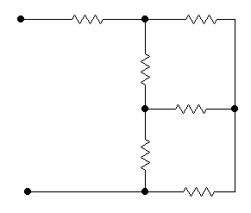 | 7  8
2. | - Find the Thevenin’s equivalent circuit for the following figure,  R_{L}  and find the maximum power transferred to the load resistance.  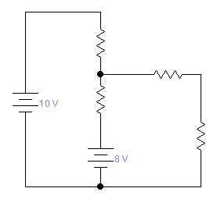  6Ω  2Ω  5Ω  - Calculate the power consumed by 8Ω resistor using Superposition theorem in fig. 3.  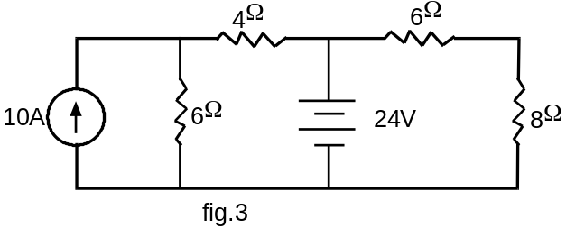 | 7  8
3. | - Find the average value, effective value, form factor and peak factor of the sinusoidal wave form.  - Two impedance of (10+j 5 Ω) and (20+ j 30 Ω) are connected in series across a 200V, 50Hz supply. Find current, active power, apparent power and reactive power and power factor. Also draw the phasor diagram. | 7  8
4. | - Explain and describe with a neat diagram the two-wattmeter method for the measurement of 3- phase power.  - Three equal impedance each having a resistance of 8Ω and inductive resistance of 6 Ω are connected in series in (i) Star (ii) Delta across 3-phase 400V system. Find (i) Phase current (ii) Line current (iii) Power consumed in each case. | 7  8
5. | - Draw exact equivalent circuit of single phase transformer.  - The following data refer to a 50KVA, 2200/110V, 50Hz, 1c transformer.  O. C. test with H. V. open: 380W 9.5A 110V  S. C. test with L. H. shorted: 820W 22.7A 100V  Determine the equivalent circuit parameters referred to LV side. | 7  8
6. | - Explain the characteristics of DC shunt and series motor.  - Explain working the principle of three phase induction motor. | 7  8
7. | Write short notes on (Any Two)  - Hysterisis and eddy-current loss  - Power factor and its significance  - Single phase Energy meter | 5 ×2

